**Uloha 4**

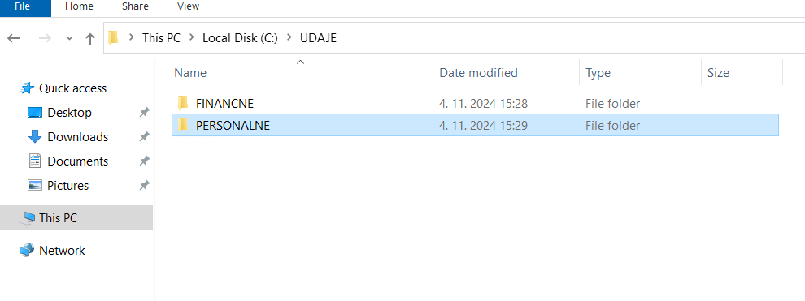

Vytvaram usera rovnako ako predtym

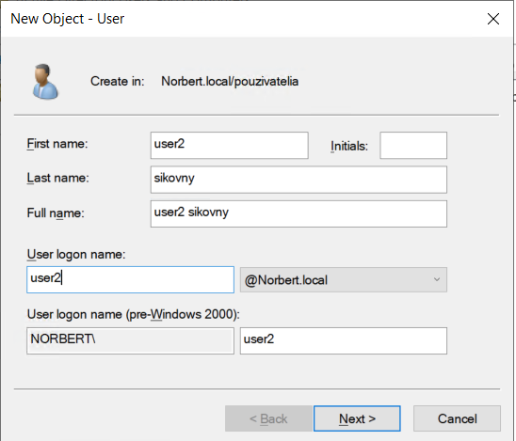

Skupiny:

Pridame do skupin

Permissions pre priecinok UDAJE:

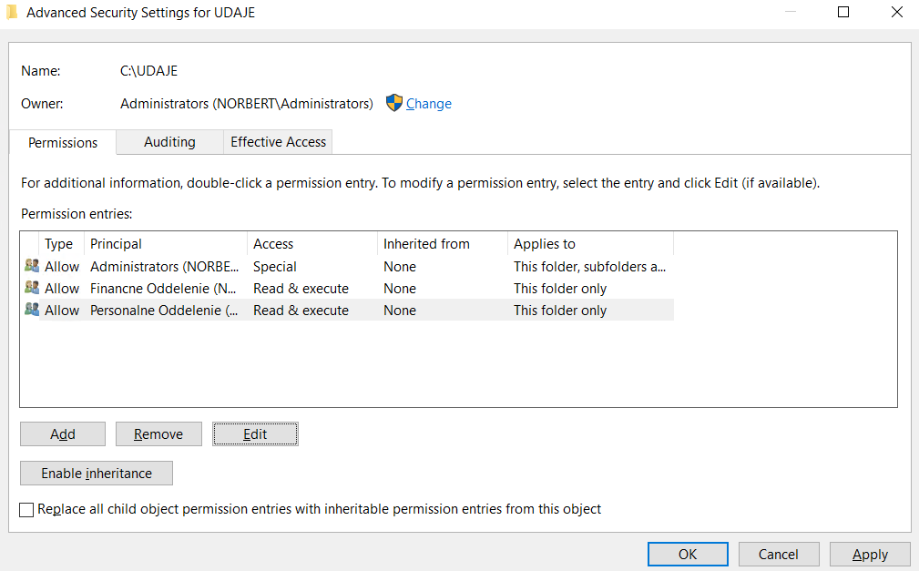

(Read & execute preto aby mohli ZOBRAZIT co sa da jedine s R&E)

Financne permissions

Personalne:

**Dokumentacia skusania:**

Za admina mozme prehliadat:

Aj prepisovat:

User2 pokus o pristup do priecinka FINANCE

User2 zapis

Ked sa pokusime vytvorit novy priecinok v UDAJE, podla ikonky vidime ze to pyta administratorkse prihlasovacie udaje a teda nemame prava

Norbert Sikovny pokus o pristup do personalne

Norbert pokus o zapis v group priecinku

To iste pri Norbert ak sa pokusime vytvorit priecinok v priecinku UDAJE tak nam to nedovoli bez administratora

**Úloha 5**

Program certutil je nastroj cmd urceny na spravu certifikatov. Utocnici ho mozu zneuzit na stahovanie suborov z internetu pomocou prikazu certutil -urlcache -split -f URL, cim by mohli obchadzat bezpecnostne opatrenia.

Vytvorime novy GPO a klikneme na edit

Prvotne nastavime firewall pokym nevytvorime nejake rules:

Chceme pridat pravidlo do outbound rules pre certutil

Vyberieme blokovat pripojenie

Blokujeme na vsetkych profiloch.

hotovo